DAY 14 REPORT
TASK - Seaborn and Graph Creation:
Introduction
Seaborn is a Python data visualization library used to create attractive and statistical graphs easily. It is built on top of Matplotlib and provides simple functions for creating different types of visualizations with less coding.

Import Statement
import seaborn as sns
import matplotlib.pyplot as plt

Difference Between Matplotlib and Seaborn
Matplotlib | Seaborn
Basic visualization library | Built on Matplotlib
Needs more coding | Needs less coding
Simple graph design | Attractive graph design
Used for full customization | Used for statistical visualization
Manual styling required | Automatic styling available

Graph Creation using Seaborn
1. Line Plot
import seaborn as sns
import matplotlib.pyplot as plt
x=[1,2,3,4,5]
y=[10,20,30,40,50]
sns.lineplot(x=x,y=y)
plt.show()
OUTPUT:
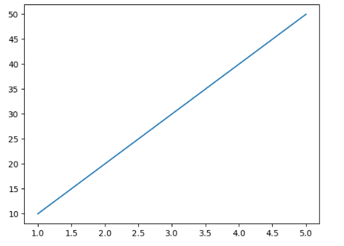

2. Bar Plot
import seaborn as sns
import matplotlib.pyplot as plt
x=[1,2,3,4,5]
y=[10,20,30,40,50]
sns.barplot(x=x,y=y)
plt.show()
OUTPUT:

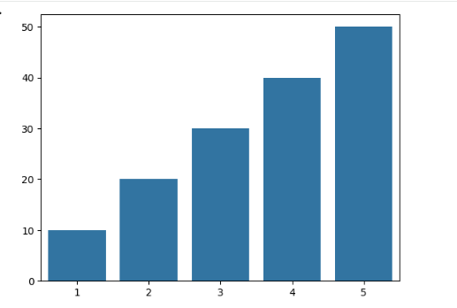

3. Scatter Plot
import seaborn as sns
import matplotlib.pyplot as plt
x=[1,2,3,4,5]
y=[10,20,30,40,50]
sns.scatterplot(x=x,y=y)
plt.show()
OUTPUT:

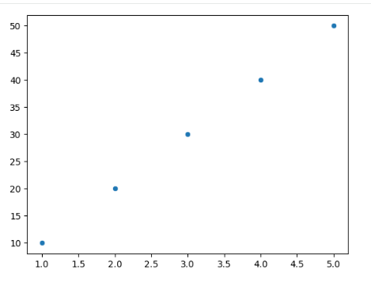

4. Histogram
import seaborn as sns
import matplotlib.pyplot as plt
y=[10,20,30,40,50]
sns.histplot(y)
plt.show()
OUTPUT:

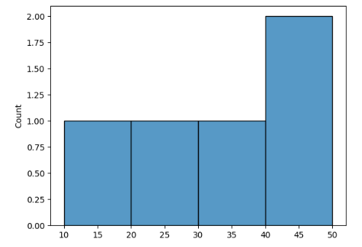

5. KDE Plot
import seaborn as sns
import matplotlib.pyplot as plt
y=[10,20,30,40,50]
sns.kdeplot(y)
plt.show()
OUTPUT:

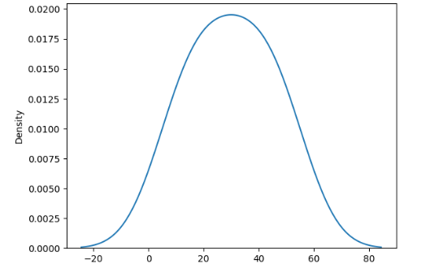

6. Box Plot
import seaborn as sns
import matplotlib.pyplot as plt
y=[10,20,30,40,50]
sns.boxplot(y=y)
plt.show()
OUTPUT:
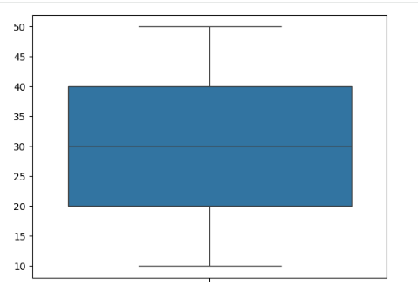

7. Violin Plot
import seaborn as sns
import matplotlib.pyplot as plt
y=[10,20,30,40,50]
sns.violinplot(y=y)
plt.show()
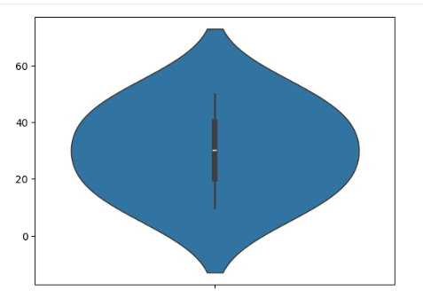

8. Heatmap
import seaborn as sns
import matplotlib.pyplot as plt
data=[[1,2,3],[4,5,6],[7,8,9]]
sns.heatmap(data)
plt.show()
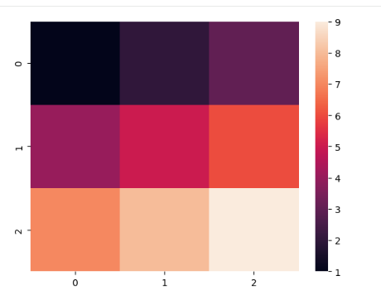
9. Swarm Plot
import seaborn as sns
import matplotlib.pyplot as plt
x=['A','A','B','B','C']
y=[10,20,30,40,50]
sns.swarmplot(x=x,y=y)
plt.show()
OUTPUT:
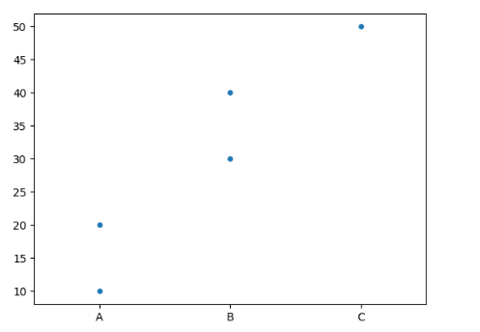
10. Count Plot
import seaborn as sns
import matplotlib.pyplot as plt
x=['A','B','A','C','B']
sns.countplot(x=x)
plt.show()
OUTPUT:
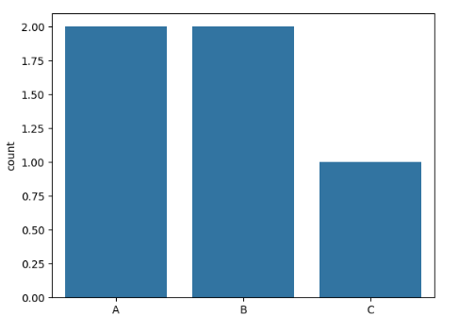
11. Joint Plot
import seaborn as sns
import matplotlib.pyplot as plt
tips = sns.load_dataset("tips")
sns.jointplot(x="total_bill", y="tip", data=tips)
plt.show()
OUTPUT:
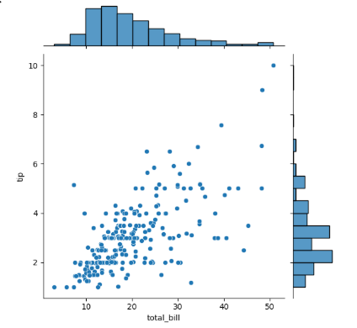

12.1Cluster Map
import seaborn as sns
import matplotlib.pyplot as plt
data = [[1,2,3],[4,5,6],[7,8,9]]
sns.clustermap(data)
plt.show()
OUTPUT:
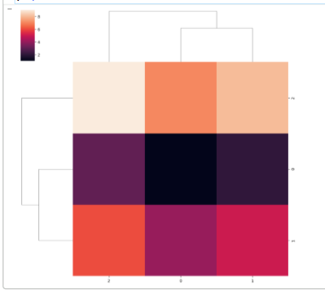

13.Relational Plot
import seaborn as sns
import matplotlib.pyplot as plt
tips = sns.load_dataset("tips")
sns.relplot(x="total_bill", y="tip", data=tips)
plt.show()
OUTPUT:
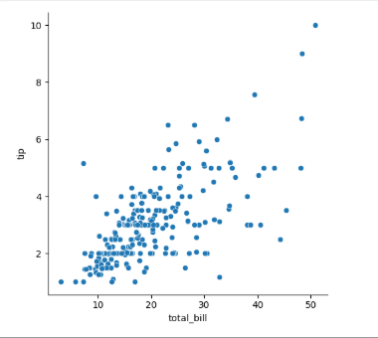

14.Categorical Plot
import seaborn as sns
import matplotlib.pyplot as plt
tips = sns.load_dataset("tips")
sns.catplot(x="day", y="total_bill", data=tips)
plt.show()
OUTPUT:
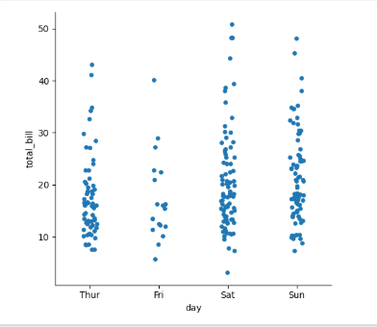

15.Distribution Plot
import seaborn as sns
import matplotlib.pyplot as plt
tips = sns.load_dataset("tips")
sns.displot(tips["total_bill"])
plt.show()
OUTPUT:
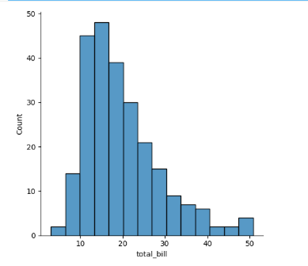
16.PairPlot
import seaborn as sns
iris=sns.load_dataset("iris")
sns.pairplot(iris)
plt.show()
OUTPUT:
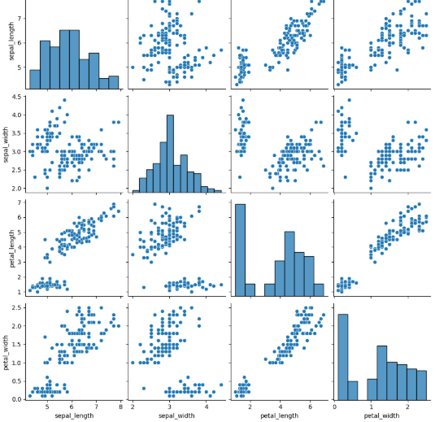
17.StripPlot:
import seaborn as sns
import matplotlib.pyplot as plt
c=['A','B','A','B','A']
sns.stripplot(x=c,y=y)
plt.show()
OUTPUT:
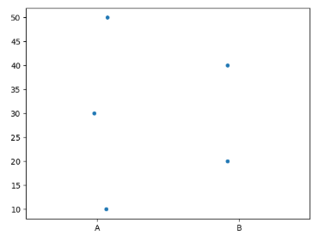
Functions Available in Seaborn
- sns.lineplot()
- sns.barplot()
- sns.scatterplot()
- sns.histplot()
- sns.kdeplot()
- sns.boxplot()
- sns.violinplot()
- sns.countplot()
- sns.heatmap()
- sns.swarmplot()
- sns.stripplot()
- sns.pointplot()
- sns.regplot()
- sns.lmplot()
- sns.pairplot()
- sns.jointplot()
- sns.displot()
- sns.relplot()
- sns.catplot()
TASK 2- Bar chart creation using SEABORN
Introduction
Seaborn is a Python visualization library used to create attractive graphs easily. In this task, a bar graph was created using Seaborn to represent student marks visually.

Program
import seaborn as sns
import matplotlib.pyplot as plt
x=["A","B","C","D","E","F"]
y=[99,90,45,95,87,65]
sns.barplot(x=x,y=y,label="Student_Marks")
plt.legend()
plt.xlabel("Student Names")
plt.ylabel("Marks")
plt.show()
Output
A bar graph displaying student names and their marks was generated successfully with labels and legend.
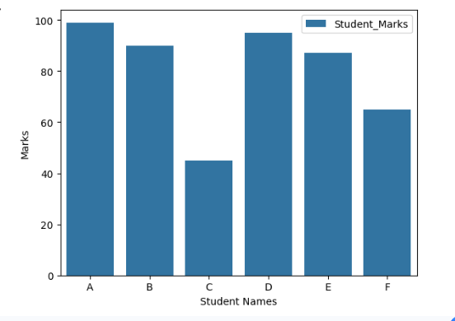

Conclusion
Today, I learned about the Seaborn library and its importance in data visualization. I understood the difference between Matplotlib and Seaborn and created different types of graphs using Seaborn functions in Python.

